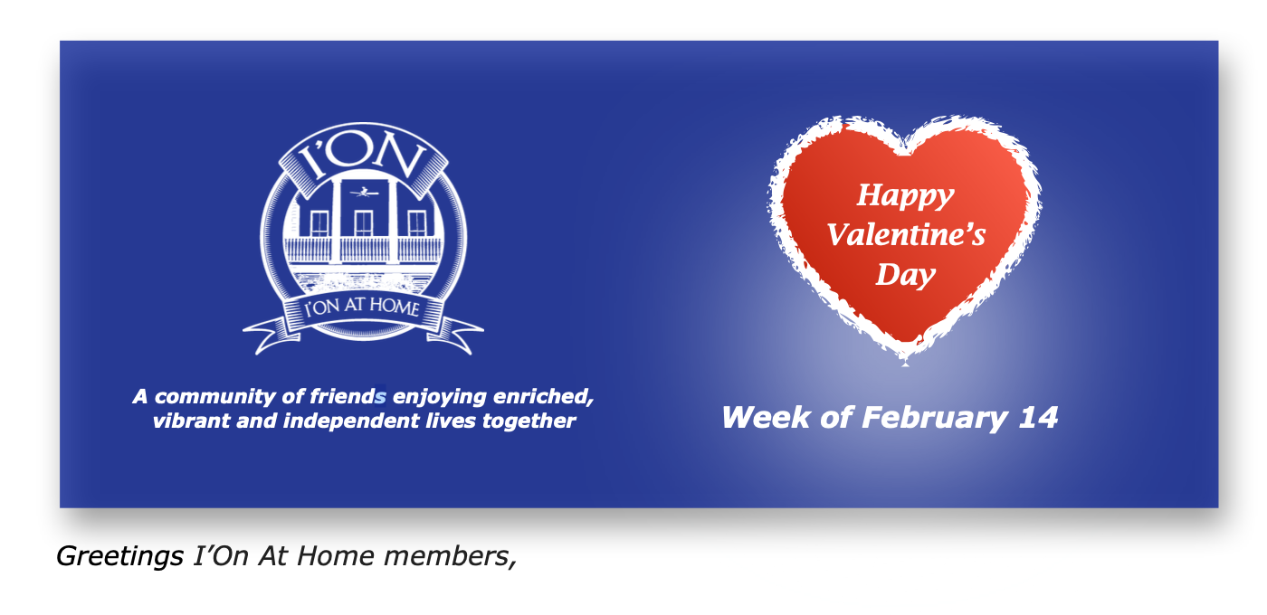
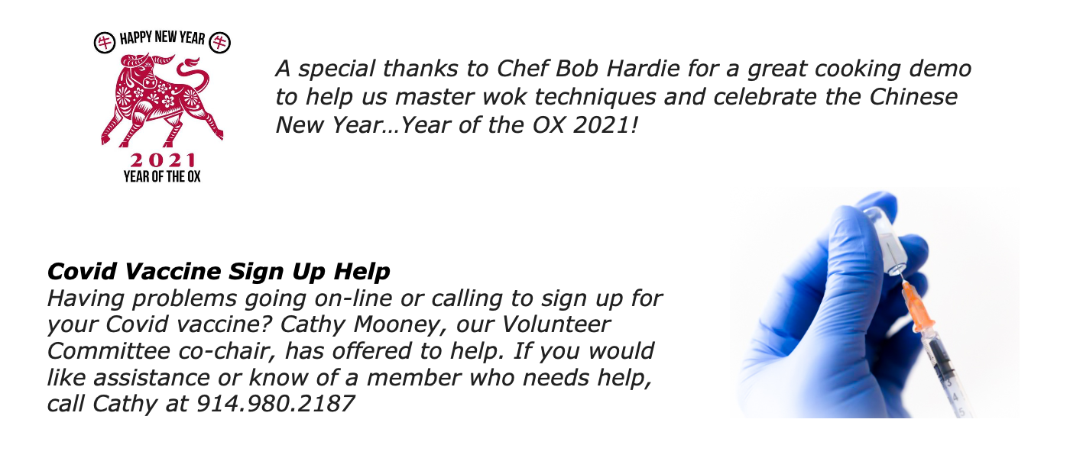
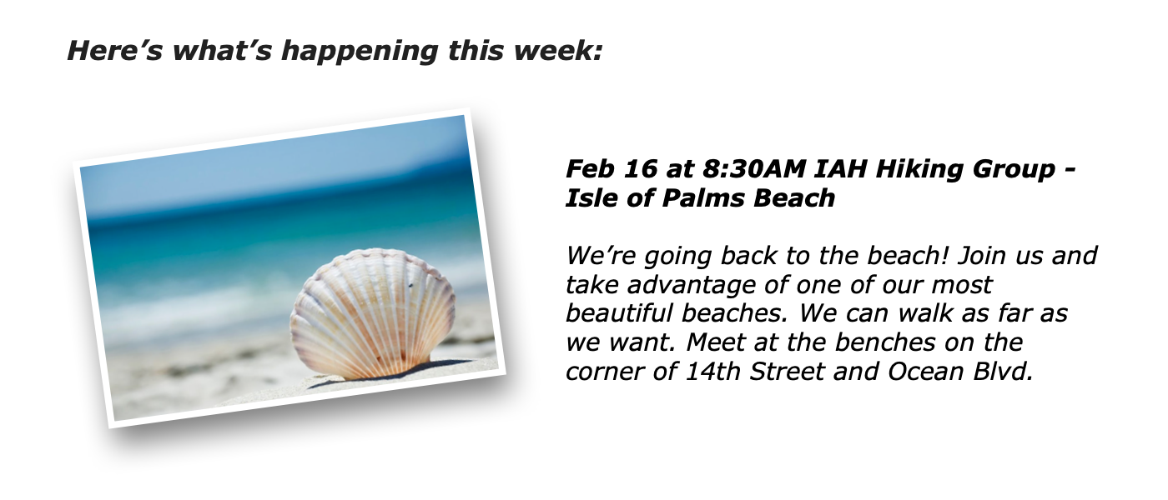
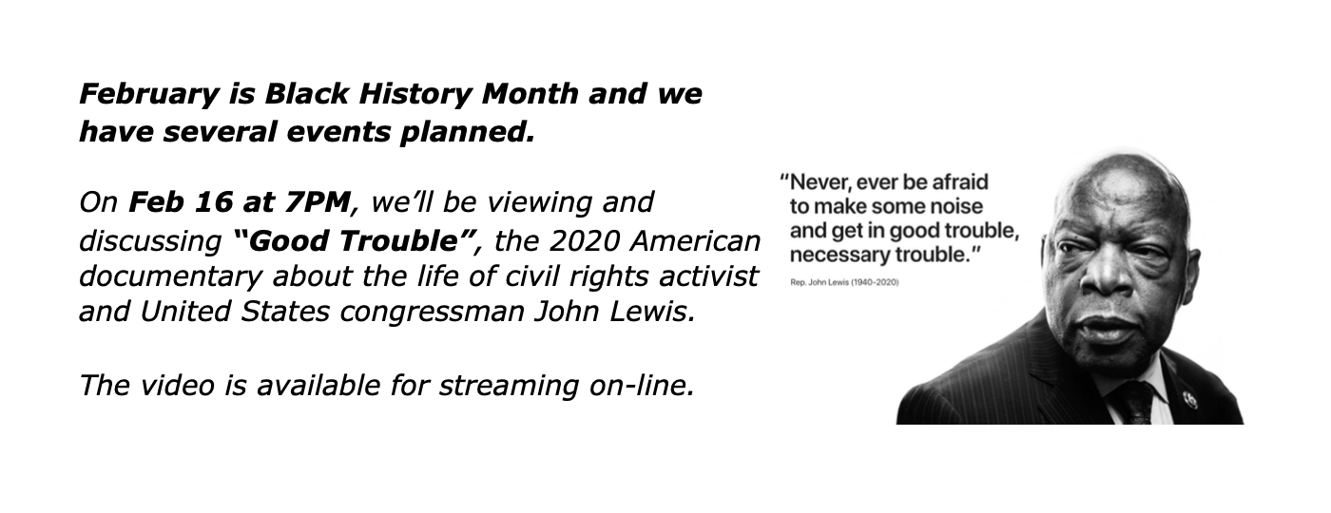
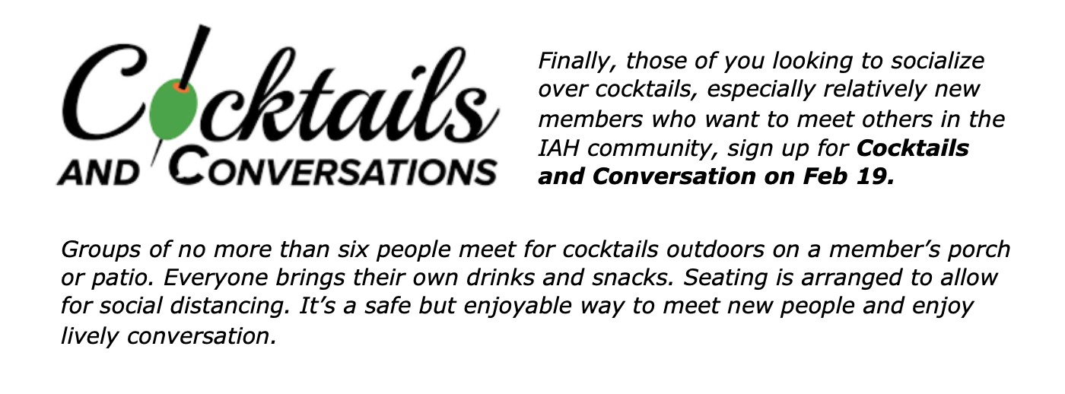
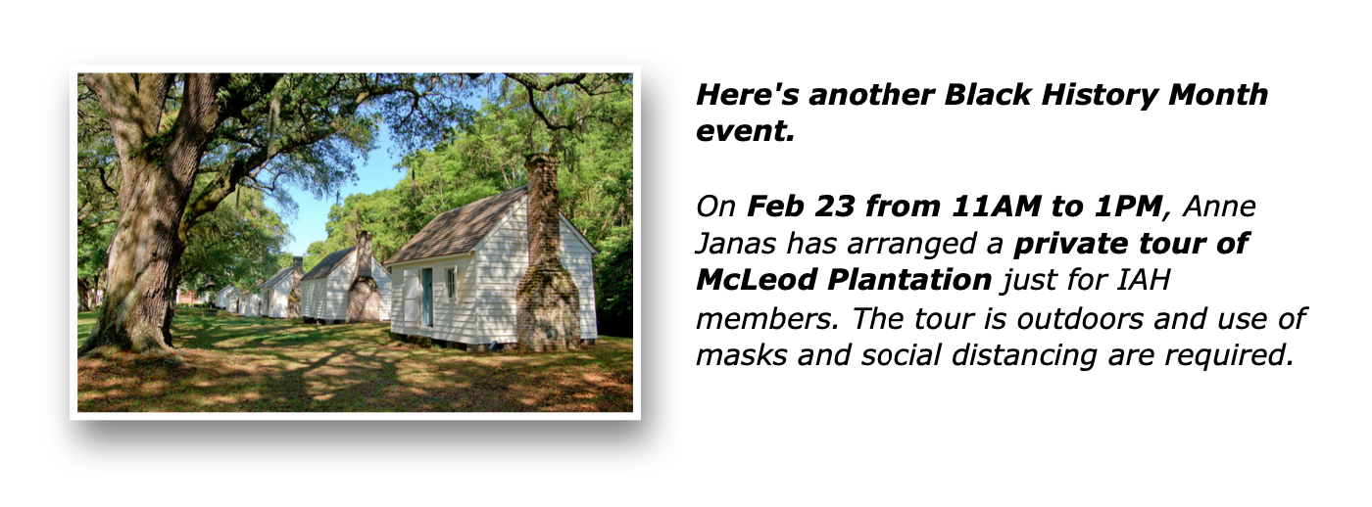
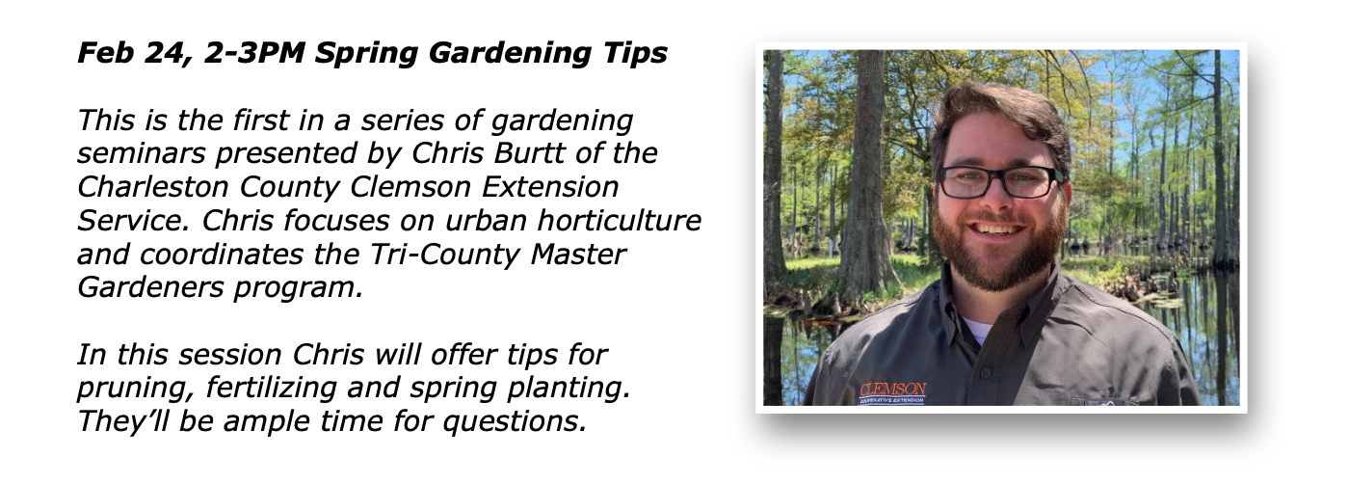
Click on: I'On At Home Events
to sign up for these and other events and programs.
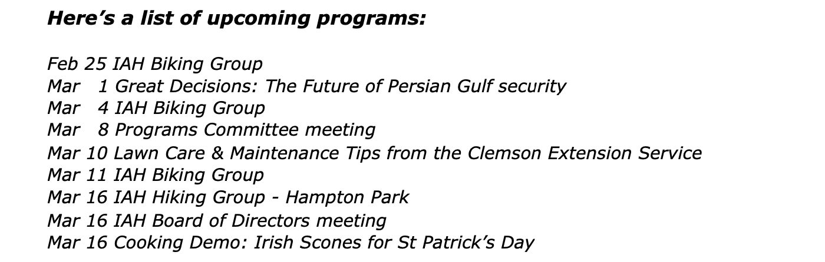
We're always searching for new subjects and activities that interest you.
Please email your ideas to:
Joe Fanelli j_fanelli@yahoo.com
Peggy Watt peggy.watt@comcast.net

We look forward to seeing you soon!
Joe and Peggy, your IAH Programs co-chairs
ALL OUR EVENTS ON THE VILLAGE WEBSITE
This Week at I'On At Home
February 14 — 20, 2021
Hiking - Beach (Isle of Palms)
Tue 02 / 16 / 2021 at 8:30 AM
Where: Isle of Palms, Corner of 14th and Ocean, Isle of Palms, SC
More Information
Board Meeting
Tue 02 / 16 / 2021 at 3:00 PM
Where: Private Home, please log in to see more
More Information
Documentary discussion: Good Trouble
Tue 02 / 16 / 2021 at 7:00 PM
Where: Zoom
More Information
Panel Discussion: “Re-envisioning America Through Diversity” by three prominent IAH members
Wed 02 / 17 / 2021 at 3:00 PM
Where: Zoom
More Information
IAH Biking Group
Thu 02 / 18 / 2021 at 9:00 AM
Where: I'On and surrounding neighborhoods
More Information
Cocktails and Conversation
Fri 02 / 19 / 2021 at 4:30 PM
Where: Private Home, please log in to see more
More Information
Next Week at I'On At Home
February 21 — 27, 2021
Outside Private Tour of McLeod Plantation
Tue 02 / 23 / 2021 at 11:00 AM
Where: McLeod Plantation, 325 Country Club Dr, Charleston, SC 29412
More Information
Spring Gardening Tips - Gardening seminar #1
Wed 02 / 24 / 2021 at 2:00 PM
Where: Zoom
More Information
IAH Biking Group
Thu 02 / 25 / 2021 at 9:00 AM
Where: I'On and surrounding neighborhoods
More Information
ALL OUR EVENTS ON THE VILLAGE WEBSITE
Thank you!
I'On At Home

