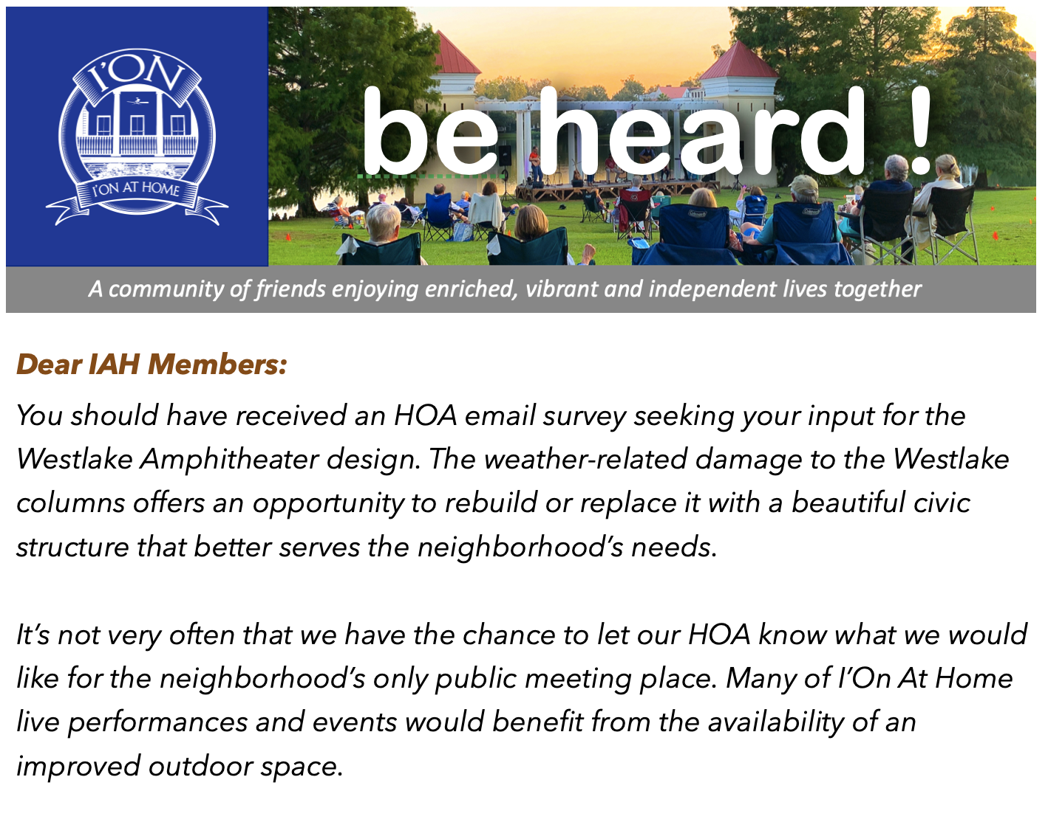

[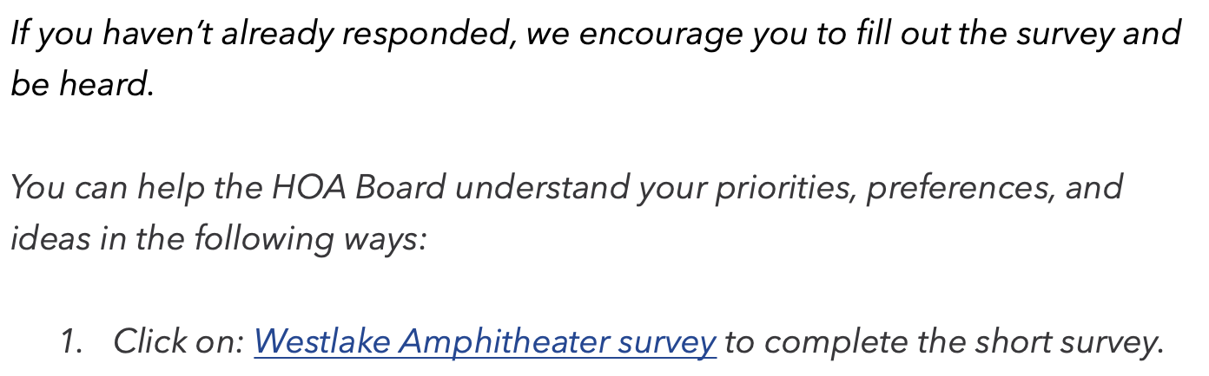](https://www.surveymonkey.com/r/GKWX3NC)

[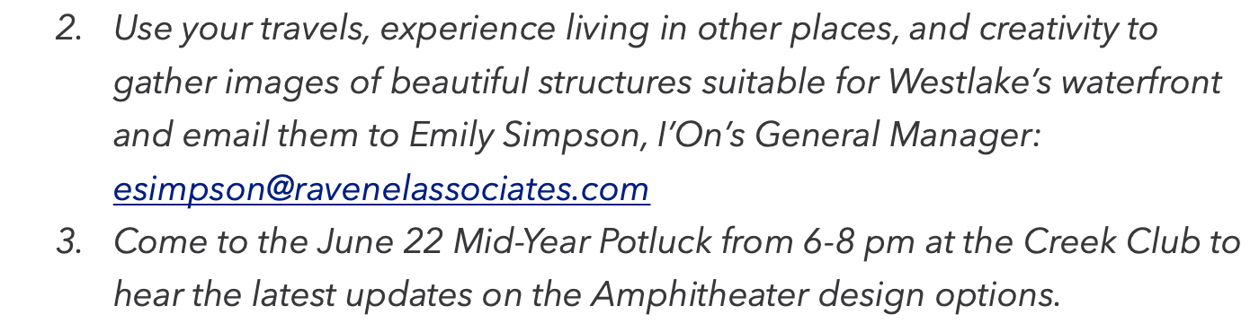](mailto:esimpson@ravenelassociates.com)

[](https://ionathome.helpfulvillage.com/events/index_list)